Git & Version Control — Concepts and Fundamentals

Objective
In this lesson, we will understand:
- What Version Control is
- What Configuration Management means in software development
- Why teams need version control
- Types of Version Control Systems
- Local VCS
- Centralized VCS
- Distributed VCS
- CVCS vs DVCS
- Why Git became important
- A brief history of Git
- What Git is
- Git features
- Git repository and working directory
- Staging area
- Commits and commit IDs
- Branches
- Tags
- Local and remote repositories
- Push and Pull
- Basic Git workflow
- Important Git commands

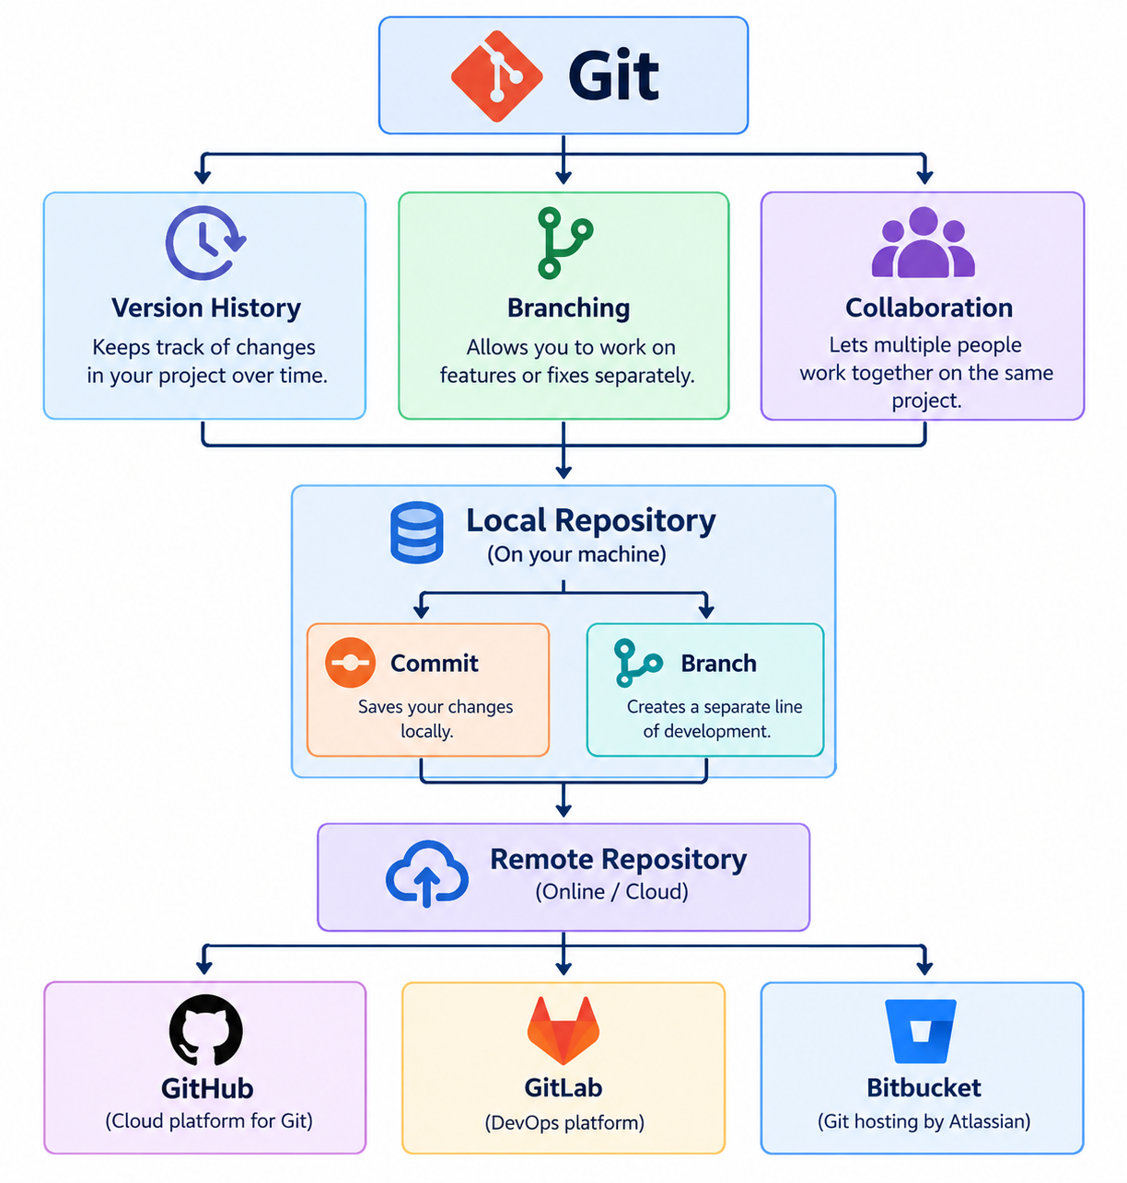

1. What Is Version Control?
Imagine a development team is creating a website.
Initially, there is only:
website/
└── index.html
After several days, different developers modify the project.
One developer changes the homepage.
Another modifies CSS.
Another adds a login page.
Without a version-control system, developers might start creating copies like:
website-final/
website-final-new/
website-final-new2/
website-final-working/
website-final-working-latest/
website-final-latest-actual/
This quickly becomes difficult to manage.
A Version Control System (VCS) provides a structured way to record and manage changes to files over time.
It allows developers to answer questions such as:
- Who changed this file?
- What was changed?
- When was it changed?
- Which version was working previously?
- Can we return to an older version?
- Which developer made the change?
- Can multiple developers work on the same project?

2. What Is Configuration Management?
Configuration Management is the process of identifying, organizing, tracking, and controlling changes to components of a system throughout its lifecycle.
In software development, these components can include:
Source code
Configuration files
Documentation
Build files
Infrastructure definitions
Deployment files
Scripts
Application settings
For example:
E-Commerce Application
|
+--- Source Code
|
+--- Configuration
|
+--- Database Scripts
|
+--- Deployment Scripts
|
+--- Documentation
Configuration management helps ensure that the team knows what changed, who changed it, and which version should be used.

3. Why Do We Need Version Control?
Consider a development team with five developers.
Developer A
Developer B
Developer C
Developer D
Developer E
|
v
Project
Without version control, several problems can occur.

Problem 1 — Multiple developers
Many people may modify the same project simultaneously.

Problem 2 — Losing previous versions
A developer may overwrite working code with a newer version containing a bug.

Problem 3 — Tracking changes
It becomes difficult to determine:
Who changed the file?
When?
Why?
What exactly changed?

Problem 4 — Parallel development
Different features need to be developed simultaneously.
For example:
Main Project
|
+---- Payment Feature
|
+---- User Profile
|
+---- Reporting

Problem 5 — Team collaboration
Developers may be working from different offices, cities, or countries.

Problem 6 — Rollback
If the latest release introduces a problem, the team may need to return to an earlier known-good version.

4. Main Benefits of Version Control
A VCS provides:
Change Tracking
+
Version History
+
Collaboration
+
Branching
+
Rollback
+
Backup/Replication
+
Controlled Releases
This is why version control is one of the fundamental tools in modern software development and DevOps.

5. Types of Version Control Systems
There are three broad models:
1. Local Version Control System
2. Centralized Version Control System
3. Distributed Version Control System

6. Local Version Control System
A Local Version Control System stores version information primarily on the developer's local computer.
Before dedicated VCS tools became common, developers often created copies manually:
project-v1
project-v2
project-v3
project-final
project-final2
This approach is simple but unreliable.

Example
Development Machine

project/
|
+--- Version 1
+--- Version 2
+--- Version 3
+--- Version 4
The developer must manage these versions carefully.

Example of a Local VCS
One historical example is RCS (Revision Control System).
RCS was designed to maintain revisions of individual files and reconstruct previous versions.

Local VCS
|
v
Version history stored locally
There is no requirement for a central server just to maintain the local revision history.

7. Centralized Version Control System
A Centralized Version Control System (CVCS) uses a central server as the primary repository.
Architecture:
Central Repository
|
+--------------+--------------+
| | |
v v v
Developer A Developer B Developer C
The central server contains the main repository.
Developers obtain files from the central server, make changes, and send their changes back.
Examples include:
- CVS
- Apache Subversion (SVN)
- Perforce

8. Basic CVCS Workflow
The general workflow looks like:
Central Repository
|
| Checkout / Update
v
Developer Working Copy
|
| Modify
v
Changed Files
|
| Commit
v
Central Repository
The central repository plays a very important role.

9. Advantages of CVCS
Centralized systems can provide:
- Centralized administration
- A single primary repository
- Straightforward permission management
- Easier centralized control for some teams
- A relatively simple conceptual model for beginners

10. Limitations of CVCS
The major limitation is dependency on the central server.
Consider:
Central Server
X
Unavailable
|
+----------+----------+
| | |
v v v
Dev A Dev B Dev C
Depending on the operation, developers may be unable to communicate changes to the central repository.
Network availability can also affect operations that require server communication.

11. Distributed Version Control System
A Distributed Version Control System (DVCS) gives each developer a local repository containing the project's version history.
Git is a DVCS.
Architecture:
Remote Repository
|
+-------------+-------------+
| | |
v v v
Local Repo A Local Repo B Local Repo C
| | |
Developer Developer Developer
Each developer has much more than just a working copy.
They have a local Git repository.

12. Why Is DVCS Different?
Suppose the remote repository becomes temporarily unavailable:
Remote Repository
X
Offline
Developers can still perform many operations against their local repository, such as:
View history
Create commits
Create branches
Compare changes
Switch branches
Inspect previous versions
Operations that communicate with the remote repository, such as:
push
fetch
pull
require connectivity to that remote repository.

13. Examples of DVCS
Examples include:
- Git
- Mercurial
- Bazaar
Among these, Git is by far the most widely used DVCS in modern software development.

14. CVCS vs DVCS
Feature | CVCS | DVCS
Main repository | Central server | Remote repository plus local repositories
Local history | Limited/varies by tool | Full repository history is normally available locally
Offline commits | Generally not available | Yes
Branching | Depends on tool; historically less flexible | Strong branching support
Server dependency | Higher | Lower for local operations
Local operations | More limited | Fast and extensive
Examples | SVN, CVS | Git, Mercurial

15. Why Git Became Important
Git was created to solve practical challenges encountered while managing the Linux kernel source code.
The Linux kernel is:
Very large
+
Many contributors
+
Parallel development
+
Frequent changes
+
Distributed contributors
The Linux kernel community had previously used BitKeeper.
In 2005, after the arrangement involving BitKeeper ended, the Linux development community needed another solution.
Linus Torvalds and contributors developed Git with important goals such as:
- High performance
- Distributed operation
- Simple underlying design
- Strong branching and merging
- Ability to handle very large projects
- Integrity of project history
Git was initially developed in 2005 and has since evolved into one of the most widely used version-control systems.

16. What Is Git?
Git is a distributed version control system used to track changes to files and coordinate work among developers.
Git is particularly popular for software source-code management, but it can track many types of files.
For example:
Application Code
Configuration Files
Shell Scripts
Documentation
Infrastructure Code
Dockerfiles
Kubernetes YAML
Terraform Files

17. Git and GitHub Are Not the Same Thing
This distinction is very important for beginners.

Git
Git is the version-control software.
It runs on your computer and maintains Git repositories.

GitHub
GitHub is a hosted platform for Git repositories and collaboration.
Other platforms include:
- GitLab
- Bitbucket
- Azure Repos
Therefore:
Git
|
+---- Local Version Control
|
+---- Local Repository
|
+---- Commit
|
+---- Branch
|
+---- Merge
while:
GitHub
|
+---- Remote Repository Hosting
+---- Collaboration
+---- Pull Requests
+---- Code Review
+---- Issues
+---- CI/CD Integration

18. Important Features of Git
Git provides:

1. Version History
Tracks project changes over time.

2. Distributed Architecture
Each clone normally contains the repository history locally.

3. Branching
Developers can work on different features independently.

4. Merging
Completed work can be integrated into another branch.

5. Local Operations
Many Git operations can be performed without network connectivity.

6. Integrity
Git uses cryptographic hashes to identify and verify repository objects.

7. Collaboration
Repositories can synchronize with remote repositories.

8. Open Source
Git is free and open source.

19. Git Basic Workflow
The fundamental Git workflow can be represented as:
Git Workflow

Working Directory
|
|
git add
|
v
Staging Area
|
|
git commit
|
v
Local Repository
|
|
git push
|
v
Remote Repository
(GitHub etc.)
For changes coming from the remote side:
Remote Repository
|
| fetch / pull
v
Local Repository
|
v
Working Directory

20. Working Directory
The working directory is the directory where the developer actually works with project files.
Example:
D:\Projects\CloudPortal\
Inside it:
CloudPortal
├── index.html
├── login.html
├── css
├── images
└── scripts
When a developer edits:
index.html
the change initially exists in the working directory.

21. Staging Area
Git provides an intermediate area called the staging area.
Suppose a developer changes three files:
index.html
login.html
style.css
But they only want to commit:
index.html
style.css
They can stage only those files.
Working Directory
|
| git add index.html
| git add style.css
v
Staging Area
|
| git commit
v
Local Repository
This gives developers control over what goes into each commit.

22. Local Repository
The Git repository stores the project's Git history and objects.
After:
git init
Git creates a hidden directory:
.git
For example:
CloudPortal/
├── index.html
├── css/
├── images/
└── .git/
The .git directory contains the information Git uses to manage the repository.

Important
Do not manually edit or delete files inside .git.
Use Git commands to manage the repository.

23. Initialize a Git Repository
Create a project:
mkdir cloudportal
cd cloudportal
Create a sample file:
echo "# CloudPortal" > README.md
Initialize Git:
git init
Git will report that an empty repository has been initialized.
Check:
ls -la
You should see:
.git
README.md

24. Check Repository Status
Run:
git status
Git will tell you which files are:
- Untracked
- Modified
- Staged
- Ready to commit
For example:
Untracked files:
README.md

25. Add Files to the Staging Area
Stage the file:
git add README.md
Check the status:
git status
The file should now appear as staged.
You can stage multiple files:
git add index.html style.css
Or stage changes under the current directory:
git add .

Working Directory
|
| git add
v
Staging Area
|
| git commit
v
Repository
git add does not create a permanent repository version.
git commit creates the commit.

26. Commit
Create the first commit:
git commit -m "Create initial CloudPortal structure"
The commit records the staged changes.
Now check:
git status
The working tree should be clean if there are no additional changes.

27. What Is a Commit?
A commit is a recorded point in the repository's history.
Example:
Commit A
|
v
Commit B
|
v
Commit C
Each commit contains information that allows Git to identify the recorded state and its relationship to previous history.
A commit commonly includes:
- Author
- Committer
- Timestamp
- Commit message
- Parent commit reference(s)
- Tree/object information

28. Commit ID / Hash
Git identifies commits using a cryptographic hash.
Example:
7c4e2f9a1d8b....

A Git commit is identified by a cryptographic object ID/hash. The exact format depends on the repository's object-format configuration.

29. View Commit History
Run:
git log
A shorter version:
git log --oneline
Example:
7c4e2f9 Create initial CloudPortal structure
This is useful for quickly reviewing project history.

30. Git Snapshot Concept
A common misconception is:
Git simply stores a complete copy of every file for every commit.
A better explanation is that Git records the project state as a snapshot of tracked content, using objects and references to avoid unnecessary duplication.
Conceptually:
Commit 1
|
+--- index.html
+--- style.css
|
Commit 2
|
+--- index.html changed
+--- style.css unchanged
Git can reuse existing objects for content that has not changed.

Git is a version-control system, not simply a backup utility.

31. Git Branch
A branch provides an independent line of development.
Suppose the main project is:
main
|
A
|
B
|
C
A developer wants to build a reporting feature.
They can create:
main
|
A
|
B
+------------------+
| |
C report-feature
| |
D E
|
F
The developer can work on the feature without directly changing the stable main line.

32. Why Do We Use Branches?
Branches are useful for:
- New features
- Bug fixes
- Experiments
- Release preparation
- Hotfixes
- Parallel development
Example:
main
|
+--- feature-login
|
+--- feature-reports
|
+--- bugfix-payment
After completing work, branches can be merged.

33. Main vs Master
Older Git tutorials frequently say:
master
is the default branch.
Modern Git hosting platforms commonly use:
main
as the default branch name.
The important concept is not the name.
A repository can use:
main
master
development
trunk
or another branch name.
For our training labs, we will use:
main

34. Create a Branch
Create a branch:
git branch feature-dashboard
List branches:
git branch
Switch to the branch:
git switch feature-dashboard
Or create and switch in one command:
git switch -c feature-dashboard

35. Merge a Branch
After completing work:
feature-dashboard
|
| completed
v
merge
|
v
main
Switch to the target branch:
git switch main
Merge the feature:
git merge feature-dashboard
Git will integrate the branch history.

36. Merge Conflicts
Sometimes two branches modify the same part of a file.
Example:
main
|
+---- line 10 = "Welcome"
|
feature
|
+---- line 10 = "Hello"
When Git cannot safely determine which change should remain, a merge conflict can occur.
The developer must manually resolve the conflict and then commit the resolution.
This is an important practical topic that we will cover separately when we start Git labs.

37. Git Tag
A tag provides a meaningful name for a specific point in Git history.
For example:
v1.0
v1.1
v2.0
Suppose:
A ---- B ---- C ---- D
^
|
v1.0
The tag v1.0 identifies commit C.
Later commits do not automatically move the tag.
This makes tags useful for:
- Software releases
- Production versions
- Milestones
- Deployment references

38. Local Repository vs Remote Repository
A Git project can have:
Local Repository
|
| push / fetch
|
v
Remote Repository

Local Repository
Stored on the developer's machine.
Example:
D:\Projects\CloudPortal

Remote Repository
Hosted on another system or platform.
Examples:
GitHub
GitLab
Bitbucket
Self-hosted Git server
The remote repository allows multiple developers to synchronize their work.

39. Git Push
git push sends local commits to a remote repository.
Local Repository
|
| git push
v
Remote Repository
Example:
git push origin main
Here:
origin
is the conventional name assigned to the remote repository.

40. Git Pull
git pull retrieves changes from a remote repository and integrates them into the current branch.
Conceptually:
Remote Repository
|
| git pull
v
Local Repository
|
v
Working Tree
A useful conceptual distinction is:
git fetch
↓
Download remote updates

git merge / rebase
↓
Integrate changes

git pull
↓
Fetch + integrate
The exact integration behavior can depend on configuration and options.

41. Git Fetch
git fetch downloads updates from a remote repository without automatically integrating those changes into your current working branch.
Example:
git fetch origin
This is useful when you want to inspect remote changes before deciding how to integrate them.

42. Connect a Local Repository to a Remote
Suppose a remote repository exists on GitHub.
Add it as origin:
git remote add origin <remote-repository-url>
Check:
git remote -v
You may see:
origin <remote-repository-url> (fetch)
origin <remote-repository-url> (push)
Then push:
git push -u origin main
The -u option establishes the upstream relationship so later pushes can usually be performed more simply with:
git push

43. Complete Git Workflow
The complete beginner workflow can be remembered as:
Git Workflow

Project Files
|
v
Working Directory
|
git add
|
v
Staging Area
|
git commit
|
v
Local Repository
|
git push
|
v
Remote Repository
GitHub / GitLab
For incoming changes:
Remote Repository
|
git fetch
|
v
Local Repository
|
merge/rebase
|
v
Working Directory

44. Important Git Terms
Term | Meaning
Git | Distributed version-control system
Repository | Git-managed project history and objects
Working Directory | Files currently being edited
Staging Area | Selected changes prepared for the next commit
Commit | Recorded point in project history
Commit Hash | Identifier for a commit
Branch | Separate line of development
Merge | Integrates histories/changes
Tag | Name attached to a specific point in history
Remote | Reference to another repository
origin | Conventional name for the default remote
Push | Sends local commits to a remote
Fetch | Downloads remote updates
Pull | Fetches and integrates remote changes
Clone | Creates a local copy of a remote repository
HEAD | Reference representing the currently checked-out commit/branch context

45. Important Git Commands

Repository Creation
git init
git clone

Status and Information
git status
git log
git log --oneline
git diff
git show

Staging and Commits
git add
git commit

Branching
git branch
git switch
git merge

Remote Repository
git remote
git remote add
git fetch
git pull
git push

Tags
git tag

48. Before and After Git

Before Version Control
Imagine four developers working on a project:
Developer A ----+
Developer B ----+
Developer C ----+---- Shared Project
Developer D ----+
They exchange files manually.
Problems:
final.zip
final-new.zip
final-latest.zip
final-latest2.zip
Tracking becomes difficult.

After Git
Each developer can maintain a Git repository:
Remote Repository
|
+------------+------------+
| | |
v v v
Dev A Dev B Dev C
Git Repo Git Repo Git Repo
| | |
v v v
Branches Branches Branches
Developers can commit their work locally and synchronize with the remote repository when appropriate.

49. Git vs Traditional File Backup
Git should not be considered simply a replacement for backup software.
Git | Backup
Tracks development history | Protects data from loss
Designed for source/configuration files | Designed for data recovery
Supports branches | Usually no branching concept
Supports merging | Usually no merge workflow
Tracks authorship/history | Usually focuses on restore
Supports collaboration | Usually focuses on protection
A good DevOps environment can use both Git and proper backup systems.

50. Final Concept Diagram

51. Key Points
Remember these points:
1. VCS tracks changes over time.

2. Configuration Management controls changes to
software/configuration items.

3. VCS models include:
Local
Centralized
Distributed

4. Git is a Distributed Version Control System.

5. Git and GitHub are different.

6. Working Directory = where you edit files.

7. Staging Area = changes selected for the next commit.

8. Commit = recorded point in Git history.

9. Branch = separate line of development.

10. Tag = meaningful name for a specific point in history.

11. Push = send local commits to a remote.

12. Fetch = download remote updates.

13. Pull = fetch and integrate remote changes.

14. Git can perform many operations without Internet access.

15. Remote synchronization requires network connectivity.

